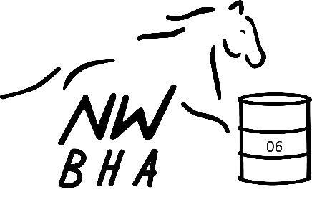
NWBHA District 06

Awards Nomination 2027

**Season points start October 1st, 2026 thru September 30th, 2027**

Date Submitted (points are earned from submission date forward):
Member Name: _______________________________________ Phone: ______________________________
Address: ____________________________________________ Email: _______________________________
Coat/Jacket Size: Preferred Colors:

HORSE 1
Registered Name (may be used for awards – please be exact in spelling):_______________________________
Barn Name (may be used for awards – please be exact in spelling):
Horse Blanket/Sheet Size: Horse Boot Size:
Class Nominating: Open $35 | Senior $25 | Youth $25 | Peewee $15 Total:

HORSE 2
Registered Name (may be used for awards – please be exact in spelling):______________________________
Barn Name (may be used for awards – please be exact in spelling):
Horse Blanket/Sheet Size: Horse Boot Size:
Class Nominating: Open $35 | Senior $25 | Youth $25 | Peewee $15 Total:

HORSE 3
Registered Name (may be used for awards – please be exact in spelling):_______________________________

Barn Name (may be used for awards – please be exact in spelling): ___________________________________
Horse Blanket/Sheet Size: Horse Boot Size:
Class Nominating: Open $35 | Senior $25 | Youth $25 | Peewee $15 Total:

*Awards participants must maintain a current NWBHA Membership. *Points will not be awarded until awards fees are paid. *Ties will be broken by race attendance. *Nomination is a horse/rider combination, with one substitute allowed per year with vet slip. Substitutes will be required to fill in for the remainder of the year. *Points will be awarded based on the fastest District 06 pointing member per race. *You are welcome to pay awards fees anytime, but if not paid by 4/30/24 the points you earned before paying the fee will not be calculated. Pee Wees do NOT need an NWBHA membership to earn awards.

Please make checks payable to NWBHA 06. Mail to: Athena Hagins, 198604 E Bowles RD, Kennewick, WA 99337

For Office Use Only:
TOTAL $ ____________ CHECK # __________ DATE: ____________ REC BY: ____________

